(Approx. 784 words)

Musings of an Apple Tyro
By Lorrin R. Garson, Potomac Area Technology and Computer Society
April 2016 issue, PATACS Posts
www.patacs.org
newslettercolumnist (at) patacs.org
First “In the Wild” Ransomware for Apple
In early March, the first successful ransomware targeting Apple computers was reported. Hopefully by the time you read this the problem will have been sorted out. The ransomware is called “KeRanger” and infects Macs by being attached to a BitTorrent client for OS X. After “KeRanger” is installed it lies dormant for three days then starts encrypting files by connecting with servers over the anonymous Tor network. It seems “KeRanger” is also attempting to encrypt Time Machine backup as well. If you use a BitTorrent client versions 2.90 or 2.91 on your Apple computer you are strongly advised to go to https://www.transmissionbt.com/ to upgrade to version 2.92. Also see http://cnet.co/1P3LNI5 for general information.
PC Sales Down but Apple Up
Sales of PC continued to drop in 2015 but not for Apple, which experienced the opposite by increasing sales by 5.8% over 2014. As can be seen in Figure 1 (from http://bit.ly/1TjnWdG), Apple now occupies the 5th position in PC sales with Lenovo being number one.

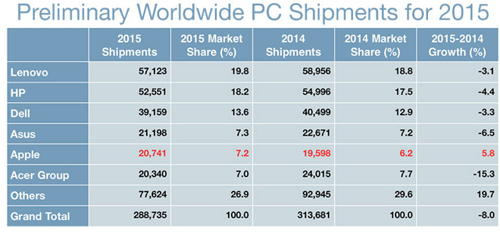
Figure 1
Sales of PCs dropped 8-9% in 2015 compared to 2014 (see http://bit.ly/1ok6gn3). In fact, sales of PCs have dropped in the past four consecutive years as the public increasingly uses smart phones and tablets to find information and communicate.
Backup of Especially Important Data
Certainly it is prudent to backup your entire computer system, but there are some data that are particularly important. I suggest these are data associated with OS X Mail, Contacts, Calendars, Reminders, and Notes. See http://apple.co/1TRZNgv for excellent information on how to backup these data plus other data types associated with iCloud.
Monitoring Memory Use
If your Apple computer seems to be running slow, it would be sagacious to check memory usage to see if that’s the bottleneck. In fact, it may be good practice to check memory usage from time to time just to see what things look like under normal conditions and take notice of which programs are memory hogs. To see how memory is being used on your machine (using OS X El Capitan v. 10.11.3), go to the Utilities folder (directory) and double-click on “Activity Monitor.app”. Then left-click on the “Memory” tab and sort that column so that the programs using the most memory are at the top of the column. As can be seen in Figure 2 for my iMac, the kernel uses the most memory (1.14 GB) followed by Google Earth Pro, Photoshop Elements 13 Editor, Microsoft Word, etc.

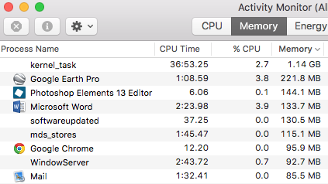
Figure 2
At the bottom of the Activity Monitor display will be a summary showing how much memory is in your computer, memory used, cached files, swap used and other information. See Figure 3. Note “Swap Used” in particular. If the system is using a lot of swap, it means your memory is heavily employed and files are being written to/from your hard drive which is a slow process, i.e., adversely affecting performance.

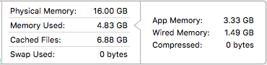
Figure 3
Computer Uptime
Want to know how long your Apple computer has been up and running since last rebooted? There’s an app for that called “Uptime”, which costs $0.99. Don’t bother. Go to the Utilities folder and start up “Terminal.app”. Key “uptime” and press return and there you have the information.
Information About All Things Apple
Expand from http://bit.ly/1pklJ78 to create a list of interesting sites for Apple information. Not all of the 20 cited Web sites will be useful; pick perhaps 6-10 of the best. Also, Google “apple computer web sites” and see what fall out. And then there are other interesting Web sites…
- See http://bit.ly/1QRpvLP.
- See http://bit.ly/1MbDfiv.
- See http://bit.ly/1pcOGRU.
Really Big SSD
Everyone is aware that capacity of disk drives has greatly increased over the years. Samsung is now shipping a 15.36 TB solid state drive that fits in the palm of your hand (Figure 4). All this in a 2.5-inch enclosure. A big book, around 1,000 pages, contains about 5 MB of text. This drive would hold 3 million such books! See http://bit.ly/1MbDGcy.

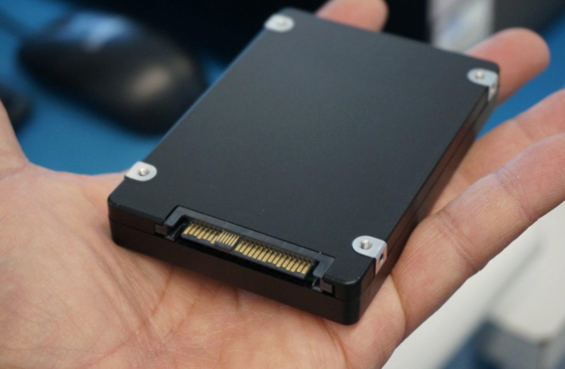
Figure 4
Noteworthy Web Sites
See http://alternativeto.net/ to locate software alternatives. This is a good source to find alternatives for Windows-based machines, Apple devices, Linux computers and more.
See http://krebsonsecurity.com for an excellent, authoritative source of what is going on in the area of security breaches and related topics. It’s a “Who’s Who” of who is being hacked and scammed.

In Figure 2, the display has been truncated on the right side and the number of processes (programs) continues on for several pages. This is an abbreviated version for the purpose of illustration.

